Requirements:

1. Reset password option for staff and client on login page.
2. Home page slider setup
3. Link staff DB data to be viewable on staff account*.*
4. Activate registration for Client role on login or register page - *All data entered by client on registration page should be viewable to super admin.*

I need a quote and a schedule for the deliverables based on the tasks.

1 - A slider as a Home page for Cro Promotions .com leading to pixidium.net as the first point of contact for users where they can login or register.

Home page Slider plugin or custom development: quote on both setups

With Heading – 10 fonts – mix of [serif] and [sans serif] fonts [Helvetica and Times]

Sub Heading – same mix as above

Text field – same feature as sisters

BG- replace image function

Let’s aim for this one

<http://preview.themeforest.net/item/elegant-responsive-html5-w-animated-metro-slider/full_screen_preview/5440458?_ga=2.265149830.803981212.1589522873-691736826.1589522873>

or this one

<http://preview.themeforest.net/item/hervin-creative-ajax-portfolio-showcase-slider-theme/full_screen_preview/23817476>

Sliders User Flow:

User swipes through 3 slides and then choose options:

[**LOGIN**] 🡪 <https://www.pixidium.net/login>

[**NEW TO PIXIDIUM?** 🡪 Register]

**Staff** – *staff data entries should be shown in the staff’s account and viewable from super admin.*

**Client** - *Client data entries should be shown in the client’s account and viewable from super admin.*

2 - We need to reactivate the client subscription on pixidium.net alongside staff subscription on login page. - *The feature is already completed by our previous developer but it was deactivated. Fig 0.1*

Reset password feature for client and staff:

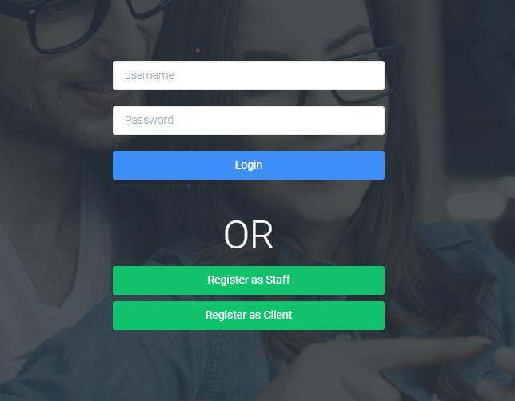 *fig 0.1*

3 - CSS edits: Create campaign page – please edit titles in line with the print scr fig 0.2.

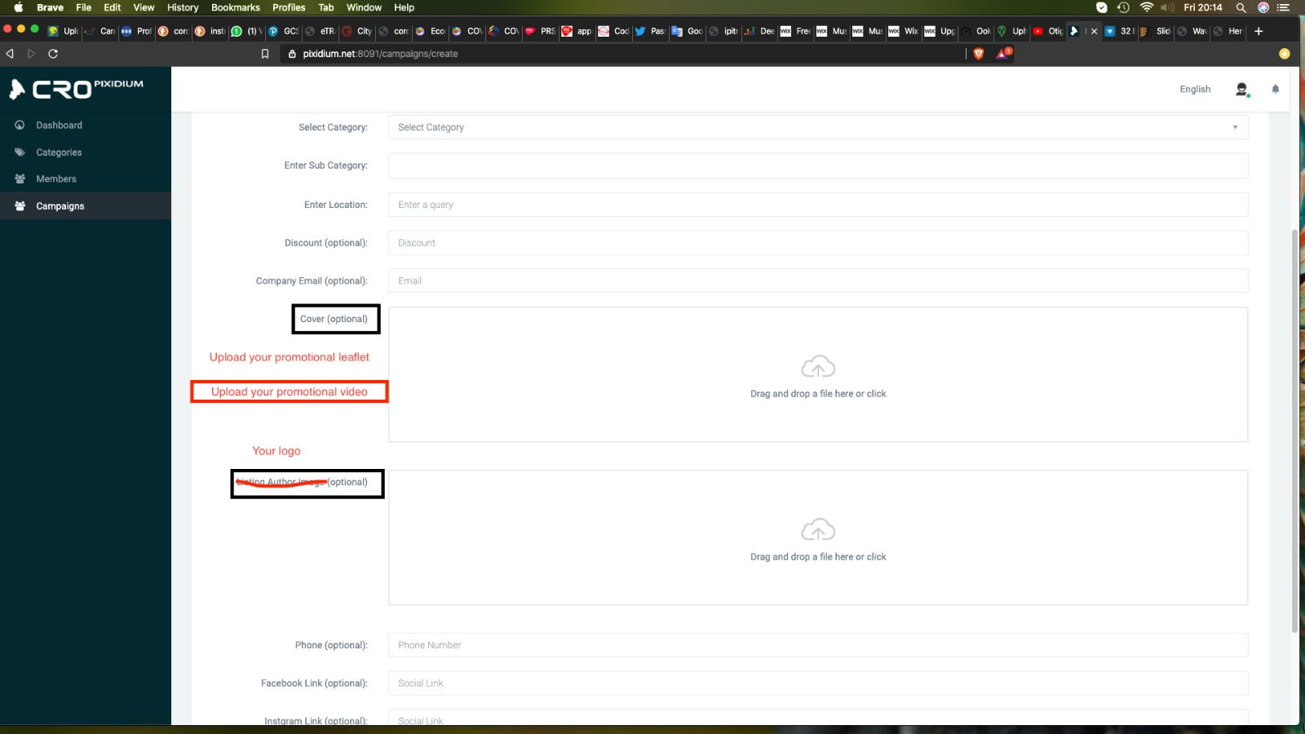 *fig 0.2*

4 - Set filters features for User roles on super admin fig. 0.3

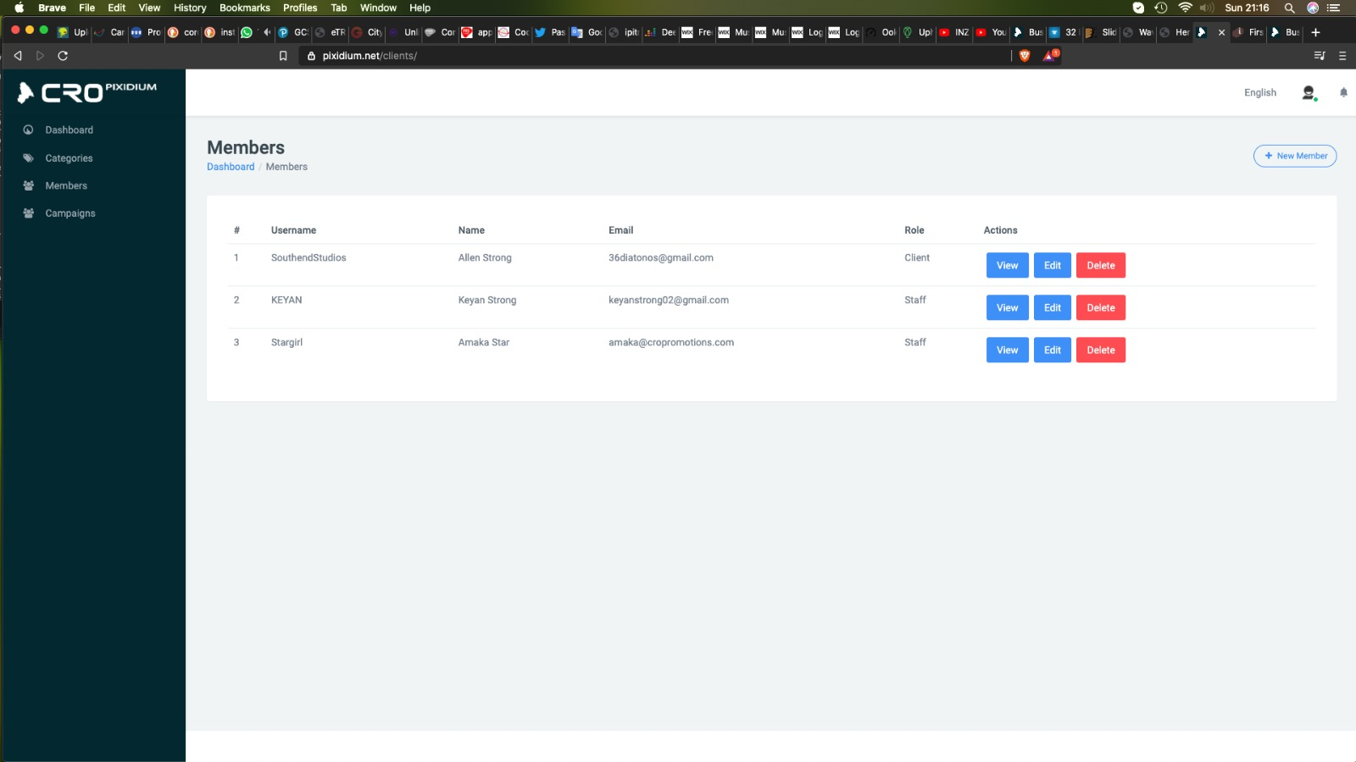 *fig0.3*

4 - Set up pay point for staff through stripe Api.

Instant payout:

Instantly request Payouts including weekend and holidays. <https://stripe.com/docs/connect/payouts#instant-payouts>

<https://www.youtube.com/watch?v=RgkaCZjy7ck>

After staff registration and authentication, the staff can amend their bank or stripe details from their account to get their payments.

Options 1: Staff could open a stripe account and get paid directly.

Options 2: Staff could attach their bank details and be paid weekly.

5 - Video

Add a video module:

1. Upload Promotion Video into library. - *MP4 or and other video related formats* *- max 59 sec.*
2. Upload Promotion Audio into library. - *MP3 or WAVE or other formats - max 59 sec.*
3. Upload video - *using youtube, vimeo api*

The video implementation and data collection should be in-line with our current setup.

Data collection and data display for super admin, client and staff view point. i.e. dashboard.

Thanks